Dear Potential Guest Teacher:

We are pleased you have expressed an interest in being a member of our Guest Teacher workforce. We are confident that you will be able to make a significant contribution to our instructional program in carrying on the work of those instructors who are unable to attend class.

To begin the process of enrolling as a guest teacher, please complete and return the enclosed Survey and Application for Employment. If possible, please also enclose a copy of your most recent resume. In addition, you will need to be prepared to deliver proof of a criminal record check, child abuse clearance and the federal clearance. A test for tuberculosis is also required along with proof of identity. These forms are required to be filled out completely and are enclosed for your convenience.

When you arrive for your first teaching opportunity, you will be given a brief orientation. At that time you will receive the necessary classroom information along with payroll forms that must be filled out and returned by the end of the day.

Teacher certification is not required at our school if you have occupational/technical expertise in any of our programs (see 2nd page of the Guest Teacher Survey form for a listing of all school programs).

We hope you will join our instructional team at Middle Bucks Institute of Technology by completing and returning the enclosed forms.

Sincerely,
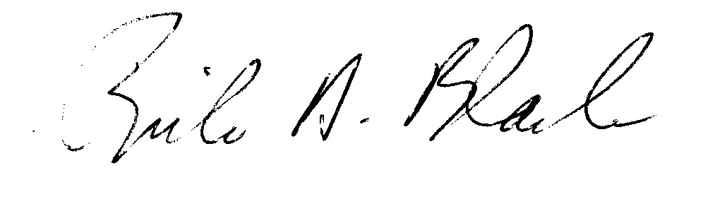

Rick D. Black
Career and Technical Education Supervisor

Enc./2012-2013

