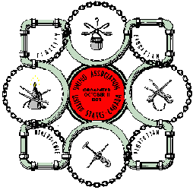
PLUMBERS
Local 690, Philadelphia

Job Description: Plumbing involves installation and repair of a wide variety of piping systems and equipment. The majority of plumbing work is in the commercial segment of building construction. From layout (or design) preparation to the final installation of fixtures and equipment a PLUMBER practices daily all the mental and physical skills acquired through a structured learning process during the five year apprenticeship period. The layout and installation of piping materials, plumbing fixtures and mechanical equipment are learned on the job. Blueprint reading, drawing, trade math, related systems, theory and selected manipulative skills are taught in the related school program. The apprentice works under the direct guidance and supervision of a licensed plumber.
Working Conditions: Plumbing is hard, physical work, and is performed throughout the year, in all kinds of weather, inside and out. Ditch work, elevated work, often involving jobs in uncomfortable positions. Potential hazards require constant "Good Safety" attitude and practice.
Recommended High School Courses: Mathematics, algebra, science, blueprint reading, drafting, and mechanical drawing.
Terms of Apprenticeship: Five year apprenticeship, 1700 minimum hours of on the job training per year. Related training, 224 hours minimum classroom instruction per year.
Admission Requirements of the J.A.C.: Application on 2nd and 3rd week of January. Qualify on aptitude test administered by the Penna. Employment Service. Personal interview.

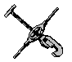
Contact: Plumbers Union Local No. 690 2791 Southampton Road Philadelphia, PA 19154
Mr. Bud Triebl, Coordinator Telephone (215) 677-6900 Ext.#45,

