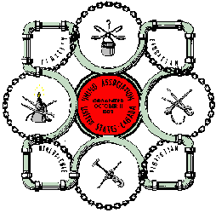
STEAMFITTERS
Local 420, Philadelphia

Job Description: Installs, and services steam and hot water heating systems; air-conditioning and refrigeration systems; nuclear and fossil fuel power plants; industrial and commercial instrument systems; cross country pipe lines; chemical and petro-chemical plants; complete environmental systems in hospitals, schools, churches, high-rise office and apartment buildings; water and sewage treatment plants, food processing plants; pharmaceutical manufacturing plants; and most other installations requiring piping.
The pipe or tubing may be copper, steel, cast or wrought iron, brass, bronze, glass, plastic, concrete or any material from which pipe can be made. The size ranges from 1/16" up to 10 feet and larger in diameter.
Joins pipes mechanically by threading, flanging, or friction joints; and metallurgically by soldering, brazing or welding- including shielded metal arc welding; gas tungsten arc welding, gas metal arc welding and oxy-fuel gas welding.
Cuts pipe and tubing using mechanical sharp wheel cutters, oxy-fuel gas cutting torches and plasma arc cutting equipment.
Must read and understand technical literature and write technical reports.
Terms of Apprenticeship: Five years of in school and paid on the job training, with pay increases each 6 months period.
General Qualifications: • 18 to 28 years of age. • High School graduate or GED. • Good math & science background.
Contact: Steamfitters' Local Union 420 Training School
14420 Townsend Road, Suite C
Philadelphia, Pa. 19154
Stephen C. Sweeney Director of Training Phone: (267) 350-2610
Fax: (267) 350-2611
Web: www.lu420.org

